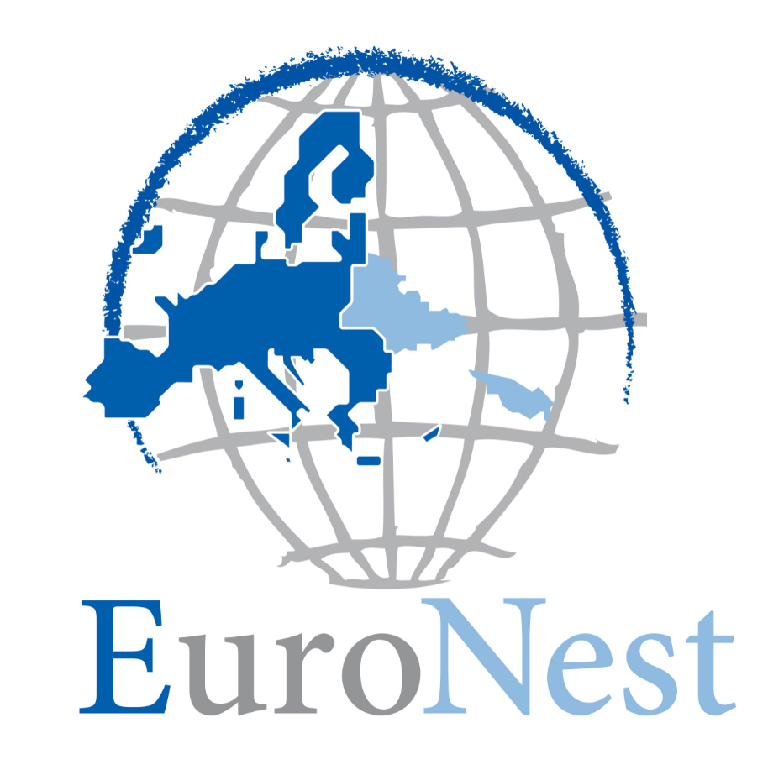 | EURONEST PARLIAMENTARY ASSEMBLY  ASSEMBLÉE PARLEMENTAIRE EURONEST  PARLAMENTARISCHE VERSAMMLUNG EURONEST  ПАРЛАМЕНТСКАЯ AССАМБЛЕЯ ЕВРОНЕСТ

Plenary session

<Date>{19/02/2023}21.2.2023</Date>
<TitreType>RESOLUTION</TitreType>
<Titre>on supporting the path of Ukraine, Moldova and Georgia towards EU membership</Depute>

Resolution by the Euronest Parliamentary Assembly on supporting the path of Ukraine, Moldova and Georgia towards EU membership

The Euronest Parliamentary Assembly,
- Noting the unwavering commitment of Moldova, Ukraine and Georgia to their EU membership goals;
- having regard to the decision by the European Council to grant EU candidate status to Ukraine and Moldova, and to recognise European perspectives to Georgia while confirming its readiness to grant the country candidate status once the priorities specified in the Commission’s opinion on its membership application have been addressed;
- having regard to the EU General Affairs Council conclusions on the Enlargement and Stabilisation and Association process of 13 December 2022, reaffirming that the future of Georgia, the Republic of Moldova and Ukraine and of their citizens lies within the European Union;
- having regard to the European Parliament recommendation of 23 November 2022 to the Council, the Commission and the Vice-President of the Commission / High Representative of the Union for Foreign Affairs and Security Policy concerning the new EU strategy for enlargement;
- having regard to the Constituent Act of the Euronest Parliamentary Assembly of 3 May 2011, Joint Declaration of the Eastern Partnership Summit of 15 December 2021 together with all previous EaP Summit Declarations, and the Association Agreements between the EU and Ukraine, Moldova, and Georgia respectively;
- having regard to the candidate status for EU membership granted to Ukraine and Moldova, and the European perspective recognized for Georgia;
- having regard to the challenges faced by the Eastern Partnership countries willing to join the EU, especially Russia’s full-scale military invasion of Ukraine as well as the aggression, occupation and hybrid threats posed by Russia, which aim to keep those countries in its sphere of influence and impede their process of EU integration;
- emphasizing the importance of the EU's continued support for the Associated Countries in their reform efforts;
- mindful of the transformative power of the European Union’s enlargement policy, and the important role it plays as a strategic investment in peace, democracy, prosperity, security and stability in Europe,
- emphasises that today the European Union and the Eastern Partnership countries find themselves at a critical juncture for the European security architecture and the international rules-based order;

- reiterates its condemnation, in the strongest possible terms, of the Russian Federation’s war of aggression against Ukraine. Reaffirms its unwavering solidarity with the people of Ukraine, who continue proving extraordinary courage and resilience under the unabated threats and attacks since 24 February 2022;

- reiterates its deep concern over Russia’s occupation of Georgia’s indivisible regions of Abkhazia and Tskhinvali region/South Ossetia, intensified annexation process and first attempt to forcibly change the borders of the sovereign state in Europe;

- reiterates its commitment to the independence, sovereignty and territorial integrity of Ukraine, the Republic of Moldova and Georgian within their internationally recognised borders and supports their efforts to fully enforce those principles;

- demands that Russia immediately terminate all military activities in Ukraine and unconditionally withdraw all forces, proxies and military equipment from the internationally recognised territory of Ukraine and permanently cease threatening or violating its independence, sovereignty and territorial integrity;

- calls on the EU and its Member States as well as on the Eastern Partnership countries to cooperate as closely as possible to stop Russia’s war of aggression against Ukraine, deter any further Russian aggressions and protect the European peace and security order;

- calls on all parties to respect the sovereignty and territorial integrity of Georgia, Moldova and Ukraine, deter Russian aggression and protect European security;

- recognizes the commitment of the people of these countries to their European future, and their contributions to stability and security in the region;

- commends the efforts of Ukraine, Moldova and Georgia in implementing reforms, and encourages them to continue on this path;

- urges their governments to continue efforts to fight corruption and ensure the independence of the judiciary;

- underlines the importance of fostering a culture of political pluralism and inclusion, as well as constructive political dialogue and parliamentary functions with regard to legislation, scrutiny and oversight;

- stresses the importance of good governance, the rule of law and fostering strong civil society and free media as essential elements for the EU accession process;

- expresses its strong support for the commitment of Ukraine, Moldova and Georgia to join the European Union, and their right to determine their own future through democratic processes;

- underlines the importance of full implementation of the key priorities indicated by the Commission in its opinions on Ukraine’s, Moldova’s and Georgia’s applications for membership of the European Union and endorsed by the European Council;

- encourages the European Commission and the European Union member states to grant the status of a candidate country to Georgia and to launch the accession negotiations with Moldova, Ukraine and Georgia;

- engages in a meaningful and structured dialogue with these countries on the EU accession process, taking into account the partic merits and specificities of each country;

- encourages the peaceful resolution of unresolved conflicts through diplomatic engagement, support for reforms, democratization and economic cooperation;

- fosters the role of Solidarity Lanes in promoting the integration of these countries into the European family, and help them overcome the obstacles and challenges that may arise on their road to EU membership;

- calls on the government of Ukraine, Moldova and Georgia to implement the EU human rights sanctions regime (the European Magnitsky Act), and extend it to include sanctions for corruption crimes, covering accession countries;

- invites the European Commission to ensure the ordered transition of Ukraine, Moldova and Georgia from EU’s association neighbors status to EU accession countries;

- invites the European Commission to ensure the ordered transition of Ukraine, Moldova and Georgia from EU’s association neighbours status to EU accession status;

- invites the European Commission to prepare tailored roadmaps laying solid grounds for the gradual accession of Ukraine, Moldova and Georgia to EU’s Single Market, on the basis of enhanced implementation of the Association Agreements and the Deep and Comprehensive Free Trade Area (DCFTA’s) with the new accession countries;

- calls following recommendations from the Conference of the Future of Europe to establish democracy partnership structures with the aim to prepare Georgia, Moldova and Ukraine to adapt to EU’s full fledged, plural democracy and values and to develop and deepen a broad citizens’ participation in the democratic life of the Union at European, national and local level; stresses that such partnerships through multinational exchange of best practices should foster and strengthen sustainable, inclusive and participatory democracies in current and future EU Member States; calls on the Commission to provide adequate financing for such partnerships;

- invites the European Commission to further explore opening the existing European Union financial instruments to Georgia, Moldova and Ukraine, bearing in mind their new status in relations to the European Union, including the Pre-Accession Instrument (IPA) to help them meet EU standards and fulfil the criteria for EU accession;

- emphasizes that the EU enlargement policy is one of the most effective mechanism to bring peace and stability to the region;

- encourages investments in energy, transport, and digital interconnectivity of the three countries with the EU to enhance energy security, boost trade, investment opportunities and economic growth, increase people-to-people contacts and ensure greater regional stability and security;

- supports the exchange of ideas, an increased cultural understanding, and greater economic cooperation and integration with the EU and among themselves by removing the financial barrier of roaming charges;

- emphasizes the importance of the continued cooperation between the Euronest Parliamentary Assembly and the parliaments of Ukraine, Moldova and Georgia, in support of their EU membership goals.

